Documentation
Team A
28.05.2024
Important Notes:
- The descriptions in italics in this document (except for some section headings) are exemplary and explanatory and must be removed from the completed report.
- Identify which section of this report was created by which team member
- Your documentation should have ca. 8 pages.

Team members
Andrew Antwan
David Gonzalez
Shahzaib Waseem

Introduction

Internet of Things
The internet of things (IoT) consist to connect everyday objects to the internet, which can collect and share the data by utilizing the environment in which they are working. Our project implements devices such as Arduino and Raspberry Pi to control a conveyor belt and robotic arm. These devices talk to each other through the internet to make the system work autonomously.

Wireless Sensor Networks
Wireless sensor networks are collections of small sensors that can sense and transmit data wirelessly, such as temperature or object detection. The color sensor and ultrasonic sensor are a part of this network in our project. They transmit data wirelessly (via an Arduino and a Raspberry Pi) to the main controllers. This facilitates wireless monitoring and control of the robotic arm and conveyor belt.

What is the target application of your project?
Our research aims to implement an automated system for sorting small colored cubes in an industrial environment. The cubes are moved by the conveyor belt; when a cube is detected by the ultrasonic sensor, the robotic arm sorts the cube according to its color. This system can help students to understand how industries sort items quickly and efficiently without needing human intervention.

Concept description

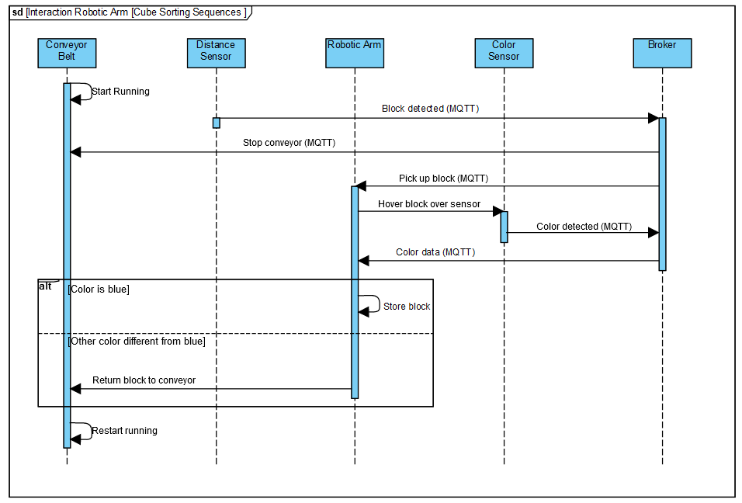
Figure 1 Sequence diagram

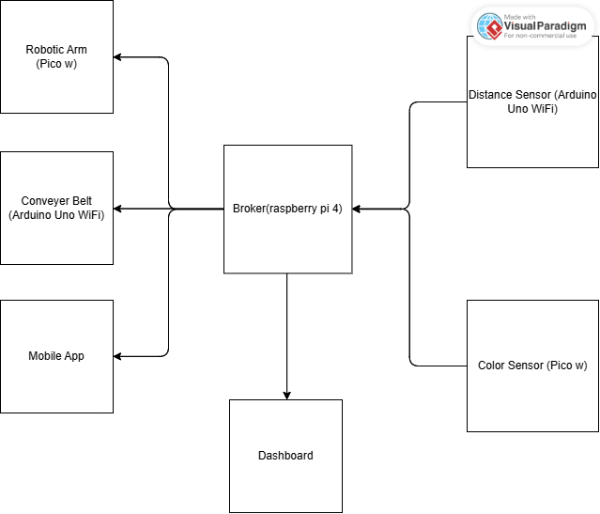
Figure 2 Block Diagram
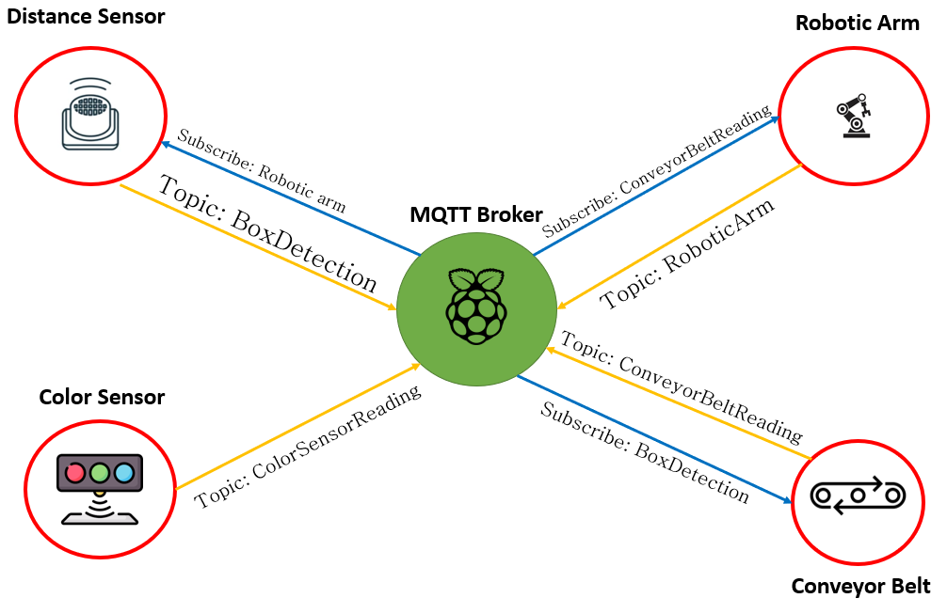
Figure 3 MQTT Communication layout

The project is mainly consisting of 4 components, namely a Color sensor, Robotic Arm, distance sensor and a conveyer belt. The operation starts by the conveyer belt where it runs until the distance sensor detects that a block has reached a specific region. The distance sensor sends a signal to both the conveyer belt in order to stop and to the robotic arm to pick up the block. The robotic arm picks up the block and hovers it over the color sensor where it sends the color detected to the robotic arm where it decides if the color is to be stored in a separate box or returned to the conveyer belt one more time.

Project/Team management

Project Methods
We used mainly GitHub as a common repository for file sharing and to sync up all our work. This allowed us to modify each others work if needed without worrying about overwriting the previous work.

Breakdown
For organizing the work we mainly met 2 times a week. One during the weekends -mainly virtually – to organize tasks and divvy up the work amongst ourselves. This was followed by another meeting in person every Tuesday where we show up the progress on the real hardware and where we would brainstorm ideas if anyone is having problems with their tasks.
We didn’t have a rigid hierarchy in the project, the assignment of tasks is mainly done on a volunteer basis depending on the ability and the vision of each.

Division of tasks
Andrew | David | Shahzaib
Color sensor code | Robotic arm code | Distance sensor code
Python MQTT library | Conveyer belt code | Conveyer belt code
Color sensor base 3d design | Robotic Arm 3d design | Arduino MQTT library
Class diagram | Distance sensor 3d design
 | Sequence diagram

Technologies

Arduino Uno Wifi Rev2
The Arduino Uno Wifi Rev2 is used as a constrained device to control both the distance sensor and the conveyer belt. It offers 48 KB of flash memory with 6.144 KB of SRAM, making it a C0 constrained device. It uses the WiFiNINA library to use the Wi-Fi functionality and the ArduinoMqttClient in order to use mqtt functionality.

Raspberry Pi Pico W
The raspberry pi pico w is used to control the color sensor and the robotic arm motors. Both of them communicate over wifi with MQTT protocol using the umqtt simple.py library. It offers stronger specs than the pre-mentioned Arduino uno wifi with 264KB of SRAM and 2MB of flash memory which offers more flexibility which is handy specially that it uses Python which compared to C++ used in Arduino programming can require larger storage space.

Raspberry PI 4
The raspberry pi 4 operates as the central hub that hosts the MQTT broker, sending and receiving all the information from the external nodes

Mosquitto
The nodes all communicate together using the MQTT protocol where nodes as distance sensor and color sensor are publishers of information and nodes as conveyer belt and robotic arm are subscribers. Keeping in mind that some nodes as the robotic arm is both a subscriber and a receiver at the same time. To use the mqtt protocol we are using the Mosquitto client on the raspberry pi 4 which offers easy setup and reliable performance.

Implementation

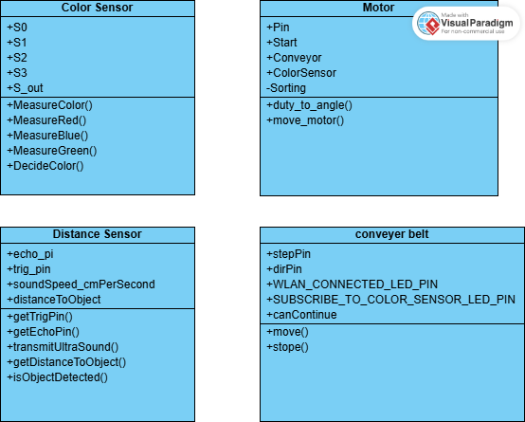
Figure 3 Class diagram

Color Sensor
The color sensor has 4 inputs in order they are S0,S1,S2,S3 and one output that gives a frequency inversely relating to the intensity of the color measured. These can be split into two groups: frequency amplification and filter. The pins S0 and S1 are responsible for amplification the measured frequency. In our code these values are set to 1 and 0 respectively to give us a scaling value of 20%. The filter pins S2 and S3 are changed depending on the required color to be measured according to the figure below.
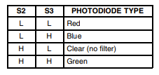
Figure 4 S2 and S3 assignment
These pins are changed using the methods MeasureRed, MeasureGreen and MeasureBlue.
The values received from each function are being compared by the DecideColor function and sees the lowest in the RGB values receives and sets this as the “result” of the measurements.

Motor
The motor class starts by defining the input pin where the motor is connected and some constants for the various positions the motor will be in. these are the values of the degrees each motor needs to be set to in order to catch the cube from the conveyer belt, hover over the color sensor, store it in the box and return to the start position one more time.
Since the motors need an input of different PWM duty cycles instead of degrees, the function duty_to_angle that transforms the duty cycle to the needed angle. This is then fed into the move_motor function to move to the desired position.

6.3 Distance sensor

The distance sensor class is based on the HCSR-04 proximity or distance sensor and contains two private attributes: the trigger pin and the echo pin. These two attributes are needed in the constructor of the class to instantiate an object of this class. The class uses methods like transmitUltrasound, and getDistanceToObject which although are available for the user to access and use, are mainly components of the isObjectDetected method. This method takes in an argument for an amount of distance in centimeters which serves as a threshold to return true or false when an object is detected within this distance threshold.

6.3 Conveyor belt

The conveyor belt class have three attributes: dirPin, stepPin, and canContinue. The two pins are used in the move and stop methods. Setting dirPin to 1, and generating a 50% duty cycle PWM on the stepPin with a frequency of 1250 Hz or period of 800 microseconds will move the conveyor belt, and setting both these pins to 0 indefinitely will stop the conveyor belt. Upon receiving a message from the distance sensor, depending on the contents of said message, the canContinue property can set to 0 or 1.

Use Case
The functionality of the system makes it so that there are two possible use cases:

- To let a blue box be sorted out
- To let a non-blue box continue its journey on the conveyor belt

To use our system, the following steps must be taken:

- Place a container for sorted blue boxes at about 60 to 80 degrees counterclockwise from the robotic arm
- Activate or turn on a suitable WLAN
- Ensure that the SSID and password of the WLAN are correctly set up in all the WSNs
- Connect the Raspberry Pi Broker to the WLAN
- After the Raspberry Pi Broker connects to the WLAN, ensure that its IP address is correctly set up in all WSNs
- Provide power to each of the WSNs (robotic arm, color sensor, distance sensor, conveyor belt), and ensure they all connect to the same WLAN and establish an MQTT connection with the Raspberry Pi Broker on its dedicated IP address
- Place a blue or non-blue box on the conveyor belt, depending on the use case chosen
- With the conveyor belt powered on, allow the box to travel forward on the conveyor belt
- Wait for the selected box to get detected by the distance sensor, which would cause the conveyor belt to stop moving
- Wait for the robotic arm to pick up the box from the conveyor belt at the box’s stopping position
- Wait for the robotic arm to carry this picked up box towards the color sensor, and allow its color to be determined
- Depending on the use case chosen, wait for a non-blue box to be placed back on the conveyor belt and have it continue its movement, or wait for a blue box to be dropped off into a container
- Allow the robotic arm to return to its neutral/starting position. Then repeat from step 7

Sources/References
Provide the sources on the technologies and algorithms you used in your project (Github).

